ESET CrackMe.exe Analysis

File Signature :

md5 = 429db63eb6937538f54dd94808a454df

File Header :
crackme.zip: PE32 executable (console) Intel 80386, for MS Windows

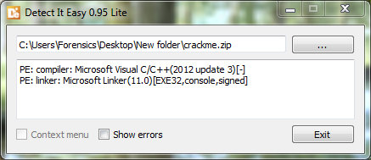

Code Overview :

Anti Debugging Protection IsDebuggerPresent .
- Anti Debugging Protection Process Environment Block (PEB).
- Three write to Terminal after Password Comparing
1- Corect Password.
2- Hint for the password.
3- Wrong Password.
- Decimal puzzle for ASCII Password .

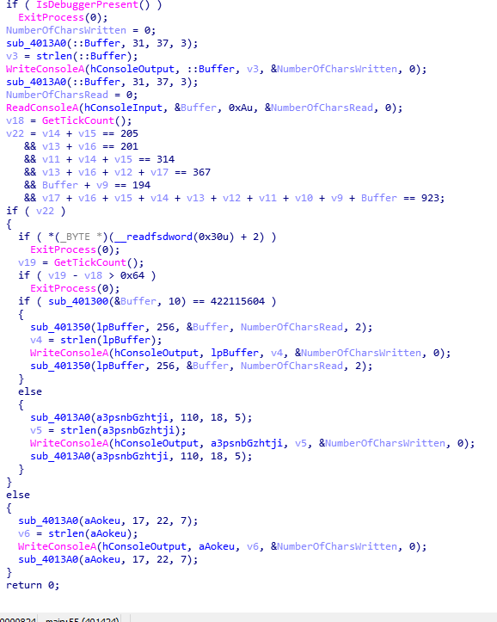

Bypass IsDebuggerPresent :

To bypass IsDebuggerPresent I Changed asm
“ test eax, eax ”
to
“ xor eax, eax ”

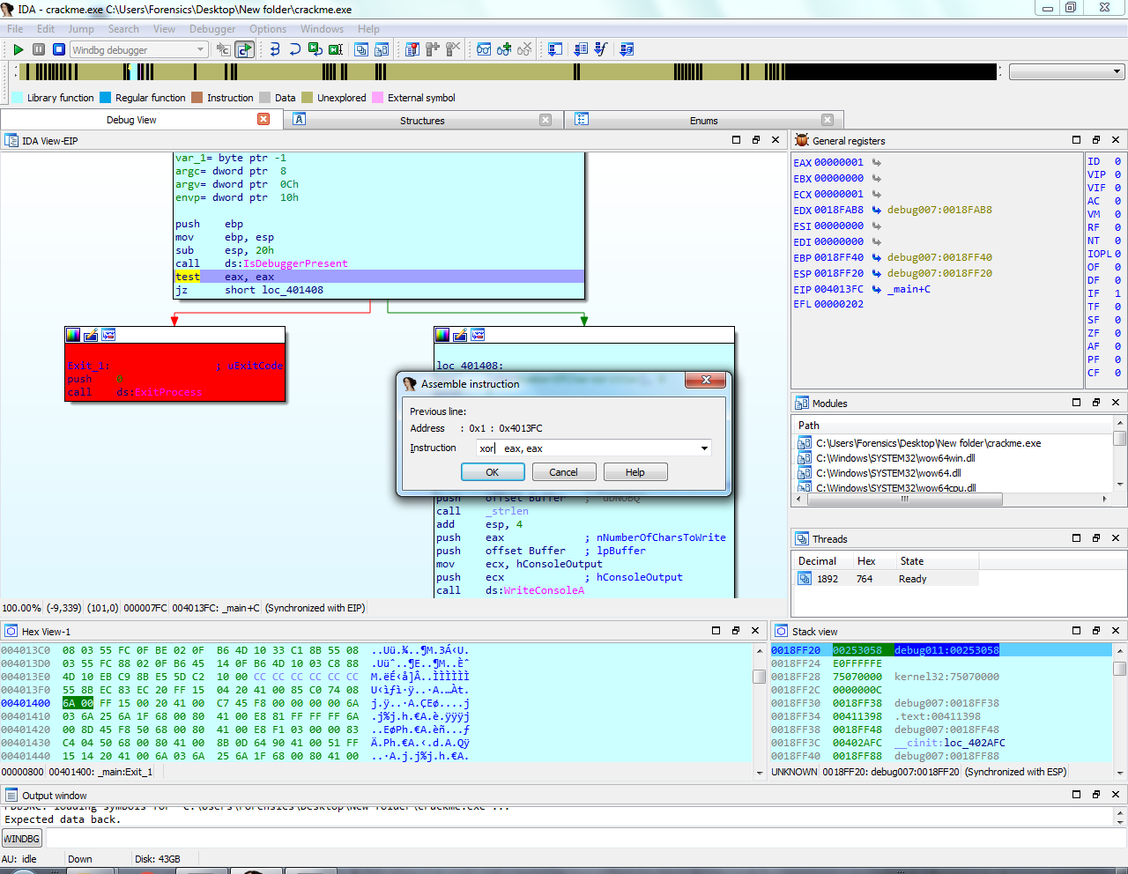

Check Input:
I Enterd the password “ABCDEFGXYZ” and checked it in the memory I found it stored with variable

(Buffer, v9, v10, v11, v12, v13, v14, v15, v16, v17)
(A B C D E F G X Y Z )

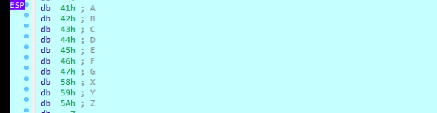

Puzzle:
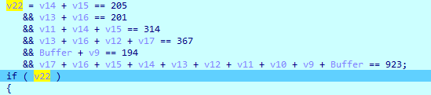

Solving Puzzle with Python and z3 :
Hint_Password = ~D0m(~~OK~

Hint message :
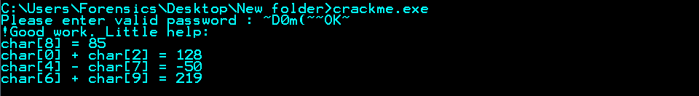

Complete the puzzle :
Password = Pr0m3theUs

Corect Password message:
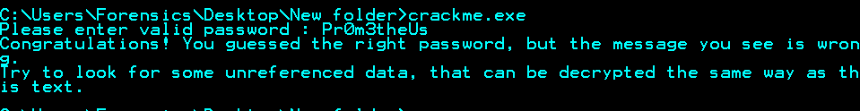

Searching for unrefrenced data:

se

Bypass the First PEB by change the ZF Flag the 0x1

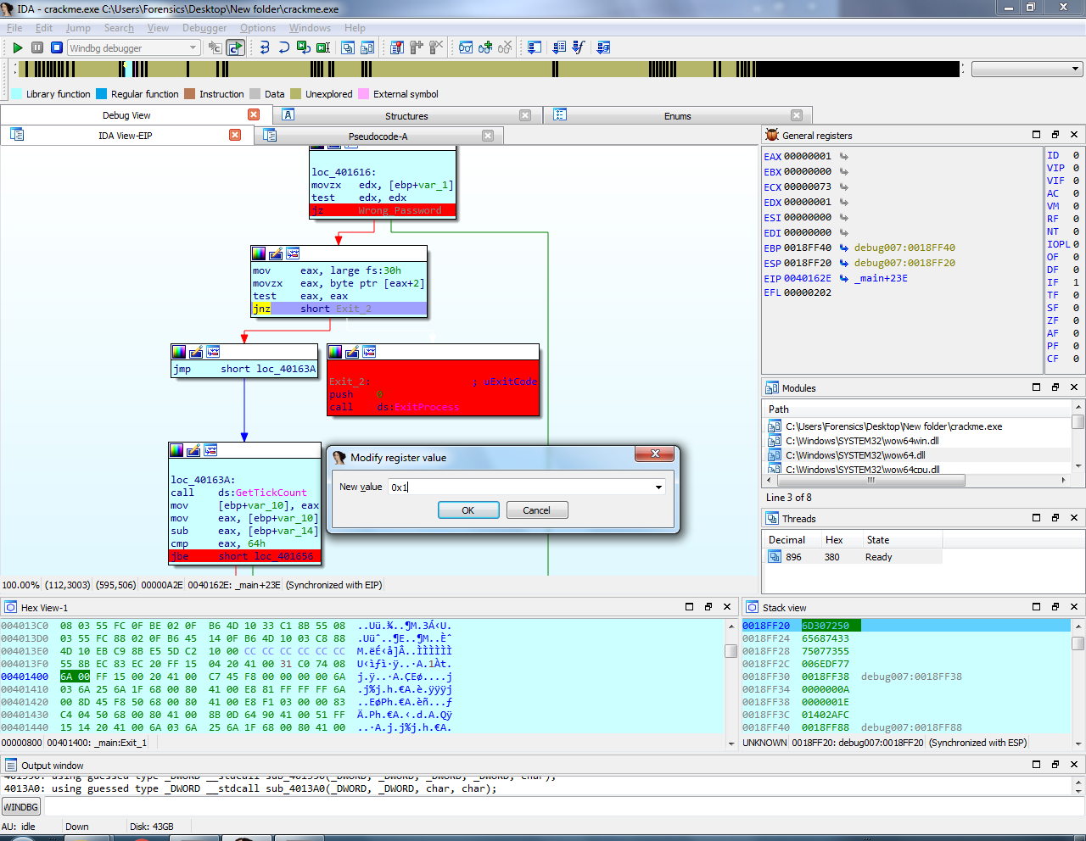
Bypass the second PEB by change the CF flag to 0x1
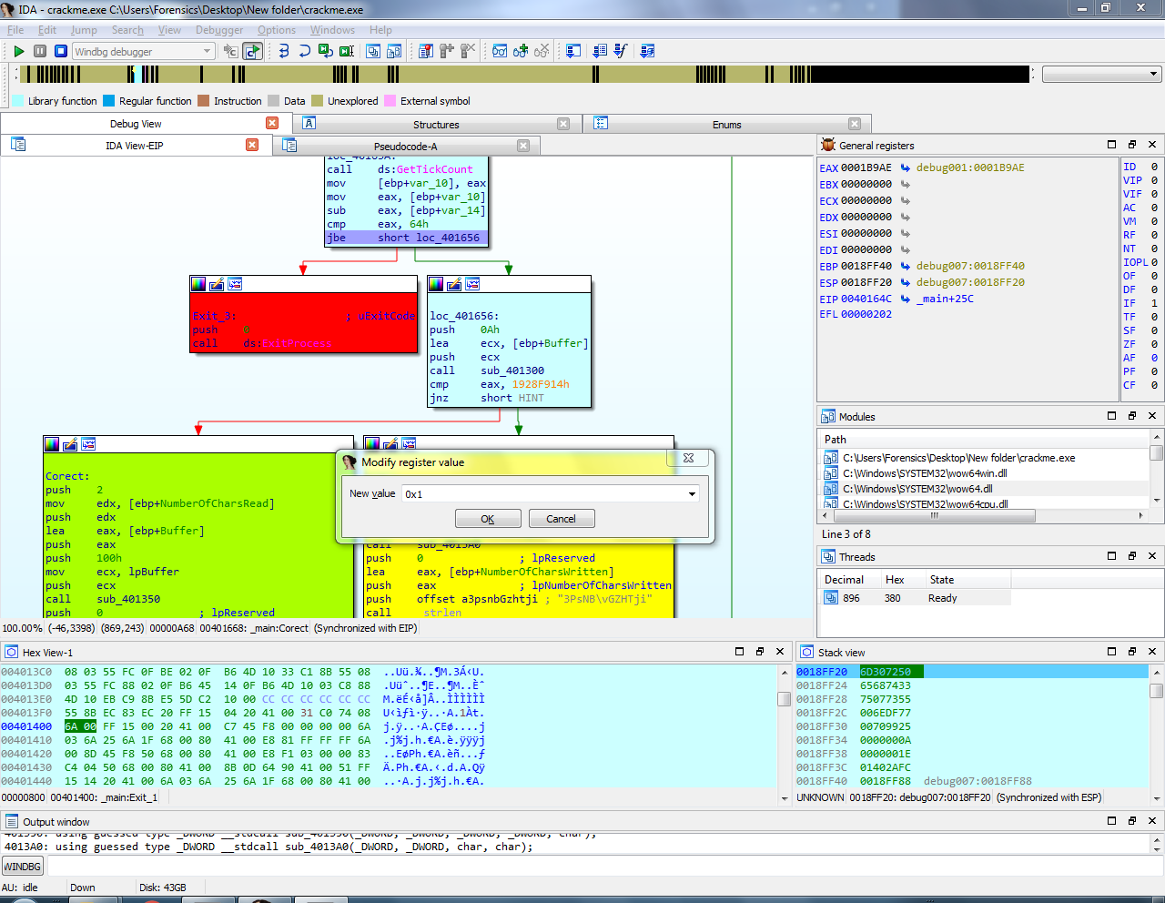
After Serching I got it :

there is string decoded as the same way with congratulation message, Hint message, and Wrong Password message using function sub_401350

the decoded message stored in EDX after decode the congratulation message

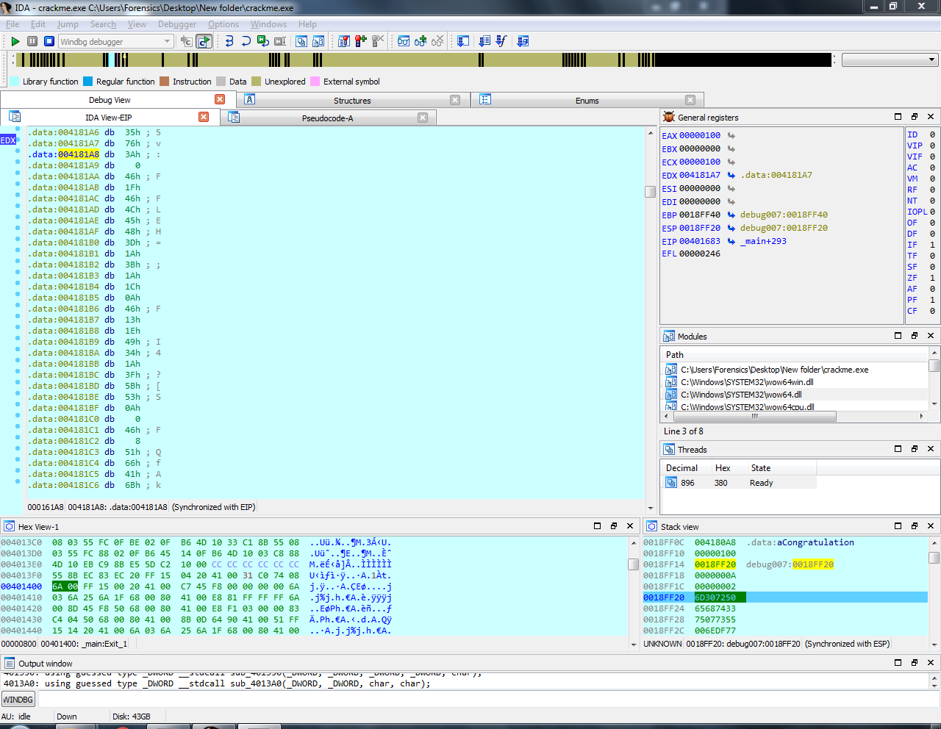

To decode this message I have changed it with congratulation message
So I changed the address of EDX before it pushed to the function with the decoded message address 004181A8
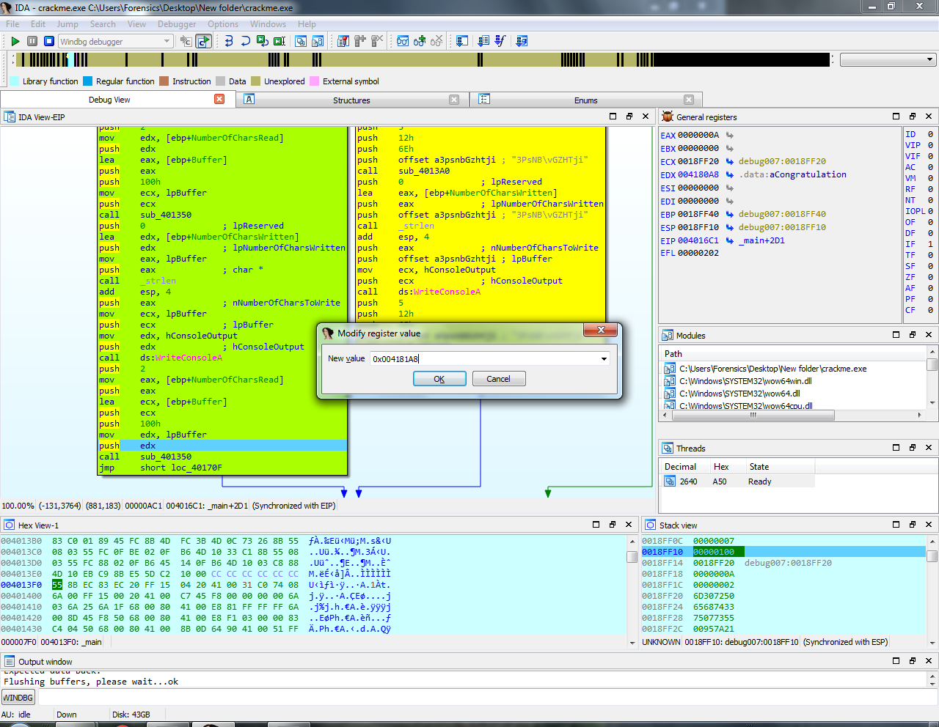

Final message after decoded:

https://join.eset.com/ae50b61499d27d7da010c718f265a9a1/crackme.zip

